Open Letter

Firstly, Board of Directors and all employees of Viet Anh Vientiane Sole Co., Ltd would like to send warmest greeting to your company. Wish your development is sustainable!
Our company also would like to send our sincere thanks to your company for having been allowing us to become a companion as well as always trusting us and using all products and services that we provided.
Viet Anh Vientiane Sole Co., Ltd was established in August 2011 in Vientiane capital, Lao P.D.R. With efforts from all staffs, our company has become the leading distributor in Vientiane Capital in the field of electrical equipment and lighting. Besides, our company is proud of contributing to successful implementation in many large projects, making prestige and satisfaction to partners and investors.
We are also a company where connect and develop talented people in many fields. We always welcome new members who have enthusiasm, good qualification, and always try to develop themselves, work together to build a business with good prestige and high competitive position in the market.
With success and prestige of Viet Anh Vientiane Sole Co., Ltd, we believe that we will bring the best satisfaction to your company.
Once again, thanks and best regards to your company!
DIRECTOR

Vo Quang Chung

INTRODUCTION

GENERAL INFORMATION
- Name of company
International transaction name in English: Viet Anh Vientiane Sole Co., Ltd
2. Address
- No. 145 Nosavanh – Saysetthay – Vientiane Province – Lao PDR
- Tel: +856 20 9925 8888/ +856 21 46 3868
- Email: vietanhvientiane@gmail.com
- Website: vietanhlao.com
3. Tax code
- Code: 107509808.900
4. Founded year
Viet Anh Vientiane Sole Co.,Ltd was established 11/08/2011.
5. Representative Director : Mr. Hat ( Lao people )
6. Bank account of company:
USD: 010 0112 000 3900 – Lao Viet Bank – Vientiane Province.
BATH: 010 02120 000 885 – Lao Viet Bank – Vientiane Province.
KIP: 010 0012 000 3038 – Lao Viet Bank – Vientiane Province.
7. Bank account of human: Vo Quang Chung
KIP: 010 0011 000 2432 – Lao Viet Bank – Vientiane Province
USD: 010 0111 000 4072 – Lao Viet Bank – Vientiane Province

ORGANIZATIONAL STRUCTURE
DIRECTOR

VICE DIRECTOR TECHNICAL
VICE DIRETOR FINANCE
VICE DIRECTOR OF HR

ORGANIZATION OFFICE
TECHNICAL OFFICE
PLANNING OFFICE
EQUIPMENT OFFICE

FINACIAL OFFICE

REPRESENTATIVE OFFICE IN PROVINCES
COMMAND OF CONSTRUCTION

WORKERS

1. Regular staffing
- | Total number of employees | 195 Persons
- | Construction engineer | 20 Persons
- | Transportation engineer | 10 Persons
- | Economic construction engineer | 03 Persons
- | Electrical Engineer | 30 Persons
- | Drainage engineer | 05 Persons
- | Geodetic engineer | 02 Persons
- | Bachelor of Economics | 10 Persons
- | Bachelor of Informatics: | 03 Persons
- | Technical Intermediate: | 50 Persons
- | Technical workers: | 62 Persons
2. Major business lines
- Specialized construction activities other
Details: Construction of industrial, irrigation and transformer stations
- Installation of other construction systems
Details: installation of machine month, escalator, cargo ladder and automobile
- Wholesaling materials, installation equipment in construction
Details: ceramic tiles and sanitary ware
- Buying and selling interior decoration
- Construction of houses of all kinds
- Trading in electrical equipment products
- Freight transport by road
- Installation of electrical systems
- Install water supply, drainage, heating and air conditioning,
- Construction of railways and road projects
- Trading in real estate, land use rights of the owner, the owner or lessee to use.

3.Social policies
Employees of Viet Anh Vientiane Sole Co., Ltd are entitled to full social allowances under the Lao labor law, regularly participate in activities of the Company's welfare fund such as study tours ...

HUMAN RESOURCES
CAPACITY EXPERIENCE OF STAFF

Position: Commander Construction

1. Full name: DANG NGOC MINH
2. Born: 02 March 1950
3. Title: Engineer
4. Major: Electrification of enterprises
School: Industrial Technology University
Graduation year: 2007
5. Permanent residence: Nghe An - Viet Nam
6. Works, projects that have participated in construction:

Project: Xieng Kouang Ethnic Boarding School - Lao PDR.

Project: Construction of the Village

Project: Xieng Kham Bank - Laos

Project: Xieng Khouang Hotel - Laos

Project: ThaGon Institute – Laos

Project to build Attapeu Hall - Laos

CAPACITY EXPERIENCE OF STAFF

Position: Commander Construction

1. Full name: BUI DUC DONG
2. Born: February 16, 1989
3. Title: Engineer
4. Major: Electrical Engineering
School: Hanoi University of Agricultural Technology
Graduation Year: 2012
5. Permanent residence: Nghe An - Viet Nam
6. Works, projects that have participated in construction:

Project: traffic lights in Xieng Khouang - Laos.

Project: Installing traffic lights in Vientiane capital

Project: Building Lao Ministry of Agriculture and Forestry

Project: Installing high speed light bulbs in Udomxay province
CAPACITY EXPERIENCE OF STAFF

Position: Commander Construction

1. Full name: NGUYEN THANH NAM
2. Born: 17 October 1979
3. Title: Engineer
4. Major: Electrical Engineering
School: Hanoi University of Agricultural Technology
Graduation Year: 2002
5. Permanent Household Registration: Can Loc District, Ha Tinh Province
6. Works, projects that have participated in construction:

Project: Renovation, upgrading and construction of new electric lighting system in Hoa Binh town, Tuong Duong district.

Project: Construction of QL1 lighting system in Northern and Southern part of Ha Tinh city under Project of expansion of QL1 North section of Ha Tinh city (Km504 + 400-Km509 + 700) and The city of Ha Tinh (km514 + 800-km517 + 950), Ha Tinh province

Project: Detention Facility 41 - Military Region 4

Project: Project to build the National Music School of Laos

CAPACITY EXPERIENCE OF STAFF

Position: Technician
1. Full name: TRAN VAN DUNG
2. Born: 25 October 1988
3. Title: Engineer of Technology
4. Major: Electrical Engineering
School: Da Nang University of Technology
Graduation Year: 2012
5. Registered permanent residence: Ha Tinh

Project: Renovation, upgrading and construction of new electric lighting system in Hoa Binh town, Tuong Duong district.

Project: Installing traffic lights in Ha Tinh city, Ha Tinh province.

Project: Construction of QL1 lighting system in Northern and Southern part of Ha Tinh city under Project of expansion of QL1 North section of Ha Tinh city (Km504 + 400-Km509 + 700) and The city of Ha Tinh (km514 + 800-km517 + 950), Ha Tinh province.

Project: Construction of Vietinbank - Vientiane – Laos.

Project: Xieng Khouang Hotel – Laos.

CAPACITY EXPERIENCE OF STAFF

Position: Technician

1. Full name: PHAN VAN KY
2. Born: November 30, 1985
3. Title: Engineer
4. Major: Electrical and Electronic Engineering
School: Vinh University of Technical Education
Graduation Year: 2012
5. Permanent Households: Nghe An Province, Viet Nam

Project: Renovation, upgrading and construction of new electric lighting system in Hoa Binh town, Tuong Duong district.

Project: Installing traffic lights in Ha Tinh city, Ha Tinh province.

Project: Construction of QL1 lighting system in Ha Tinh Province (km514 + 950), Ha Tinh province.

Project: Construction of Vietinbank - Vientiane - Laos.

CAPACITY EXPERIENCE OF STAFF

Position: Technician

1. Full name: TRINH VAN TIEN
2. Born: 22/8/1980
3. Title: Engineer
4. Specialization: Surveying
School: University of Mining and Geology
Graduation Year: 2011
5. Permanent Household Registration: Nghe An Province, Vietnam

Project: Renovation, upgrading and construction of new electric lighting system in Hoa Binh town, Tuong Duong district.

Project: Installing traffic lights in Ha Tinh city, Ha Tinh province.

Project: Construction of QL1 lighting system in Ha Tinh Province (km514 + 950), Ha Tinh province.

Project: Construction of Vietinbank - Vientiane - Laos.

Project: Xieng Khouang Hotel - Laos.

CAPACITY EXPERIENCE OF STAFF

Position: Technician

1. Full name: PHAN CONG PHUONG
2. Born: 27 August 1984
3. Title: Engineer
4. Major: Construction Economics
School: Hanoi University of Transport
Graduation Year: 2008
5. Permanent Household Registration: Nghe An Province, Vietnam

Project: Renovation, upgrading and construction of new electric lighting system in Hoa Binh town, Tuong Duong district.

Project: Installing traffic lights in Ha Tinh city, Ha Tinh province.

Project: Construction of Vietinbank - Vientiane - Laos.

Project: ThaGon Institute - Laos
CAPACITY EXPERIENCE OF STAFF

Position: Technician

1. Full name: PHAN TRONG DUY
2. Born: June 04, 1990
3. Title: Engineer
4. Specialization: Labor Protection
University: University College of Labor
Graduation Year: 2013
5. Permanent Household Registration: Ha Tinh Province

Project: Renovation, upgrading and construction of new electric lighting system in Hoa Binh town, Tuong Duong district.

Project: Installing traffic lights in Ha Tinh city, Ha Tinh province.

Project: Construction of QL1 lighting system in Ha Tinh Province (km514 + 950), Ha Tinh province.

Project: Construction of Vietinbank - Vientiane - Laos.

Project: Xieng Khouang Hotel - Laos.

CAPACITY EXPERIENCE OF STAFF

Position: Technician

1. Full name: LE BAO TUYEN
2. Born: April 26, 1986
3. Title: Engineer
4. Specialization: Construction Machinery
School: Hanoi University of Civil Engineering
Graduation Year: 2010
5. Permanent Household Registration: Nghe An Province
Project: Renovation, upgrading and construction of new electric lighting system in Hoa Binh town, Tuong Duong district.

Project: Installing traffic lights in Ha Tinh city, Ha Tinh province.

Project: Construction of Vietinbank - Vientiane - Laos.

Project: Xieng Khouang Hotel - Laos.

CAPACITY EXPERIENCE OF STAFF

Position: Technician

1. Full name:HO QUOC THAO
2. Born: April 11, 1991
3. Title: Engineer
4. Specialization: industrial and civil electricity
School: Hanoi University of Electricity
Graduation Year: 2014
5. Permanent Household Registration: Nghe An Province

Project: Renovation, upgrading and construction of new electric lighting system in Hoa Binh town, Tuong Duong district.
Project: Installing traffic lights in Ha Tinh city, Ha Tinh province.
Project: Construction of QL1 lighting system in Ha Tinh Province (km514 + 950), Ha Tinh province.

CAPABILITY OF MACHINE EQUIPMENT
EQUIPMENT MACHINERY COMPANY
- Office devices
TT | KIND OF EQUIPMENT | UNIT | NOTE
1 | Computer | 25 | Compaq
2 | Printer A4 | 07 | HP laserjet 1300
3 | Photocopy machine | 04 | SHARP
4 | Fax machine | 02 | Panasonic
5 | Phone - Mobiphone | 15 | Panasonic
2. Construction devices & Machinery
TT | KIND OF MACHINERY | QUANLITY | CAPACITY | BRAND | EXP | OWN OF
1 | Steel-cyclinder rooler Sakai | 4 | 16T | Japan | 2008 | Company
2 | Rooler | 4 | 25T | China | 2011 | Company
3 | Self-propelled excavator | 2 | 108CV | Japan | 2009 | Company
4 | Concrete mixer truck | 14 | 150L-350L | Viet Nam | 2012 | Company
5 | Rod vibrator HONDA | 16 | 1.5KW | Japan | 2012 | Company
6 | Table vibrator | 15 | 1.0KW | China | 2012 | Company
7 | Vibrator | 15 | 80kg | Japan | 2012 | Company
8 | Concrete mixer automatic | 8 | 75 l | Japan | 2009 | Company
9 | Generator | 8 | 4,5 KW | Korea | 2011 | Company
10 | Pump water machine HONDA | 8 | 50-100m3/h | Japan | 2012 | Company
11 | Welding electric machine | 10 | 23KW | Japan | 2011 | Company
12 | Steel cutting machine | 10 | 1KW | China | 2011 | Company
13 | Drilling stone machine | 4 |  | Korea | 2010 | Company
14 | Air compressor | 2 | 10m^{3/min} | Japan | 2010 | Company
15 | Air compressor | 1 | 10m^{17/min} | Korea | 2011 | Company
16 | Palang leash 5 ton | 6 | 5 ton | Japan | 2012 | Company
17 | Winches mill | 4 | 5 ton | China | 2012 | Company
18 | Pump water machine | 8 | 40-60m^{3/h} | China | 2012 | Company
19 | Richshaw power poles | 2 |  | Korea | 2013 | Company
20 | IFA water tank | 5 | 4,5 ton | Germany | 2013 | Company
21 | Crane | 3 | 10 ton | HUYNDAI | 2013 | Company
22 | Ladder car | 1 |  | Germany | 2014 | Company
23 | To 1-2 pole ( A) | 8 |  | Japan | 2008 | Company
24 | Steel – cyclinder Rooler HAMN | 1 | 18 T | Germany | 2012 | Company
25 | Stell – cylinder Rooler SaiKa | 1 | 18T | Japan | 2011 | Company
26 | Steel cutting machine GP-40 | 4 |  | Viet Nam | 2014 | Company
27 | BarbendeGQ-40A | 4 |  | Viet Nam | 2014 | Company
28 | Hoisnt | 1 | 100m | Viet Nam | 2013 | Company
29 | Electronic total station | 2 |  | Switzerland, Japan | 2011 | Company
30 | High Level machine | 2 |  | Japan | 2011 | Company
31 | Swing Gauge L402BT | 3 |  | China | 2010 | Company

- CONSTRUCTION EQUIPMENT
1 | Automatic level ( 4 chiếc) | Measure the angle of the coordinates | Japan | Company
2 | Total station | Total station | Japan | Company
3 | Sieve standard | Check the grain composition | China | Company
4 | Compactness test set | Determination of compressive strength | China | Company
5 | Sets concrete slump testing | Determination of concrete slump | Viet Nam | Company
6 | Ruler 3m | Check for flatness | Viet Nam | Company
7 | Thermometers, Amplifiers, Voltmeters | Measurement equipment | Japan | Company
8 | Thickness measurement device | Measurement of material thickness | Japan | Company

TRADE CAPACITY

Viet Anh Vientiane Sole Co.,Ltd exclusive all over the country of Laos some electrical products - lighting brands in the world:

- Civil and industrial electrical appliances – LS (LG) – Korea

- LED Lighting Oversea (Oled) Lighting - Malaysia
- High Pressure Fixture - Nikkon – Malaysia

- Cable & System LS Vina ( Technology of LS Korea )

Product image

LS – Korea:

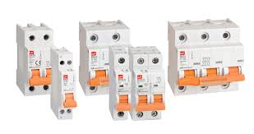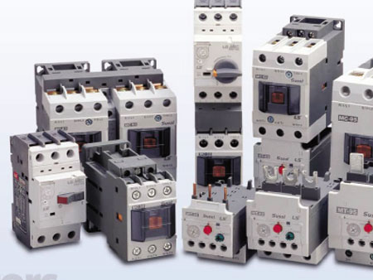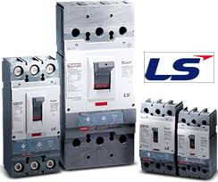

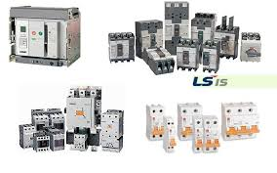

Oled – Malaysia

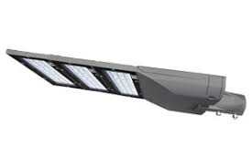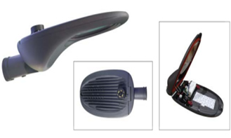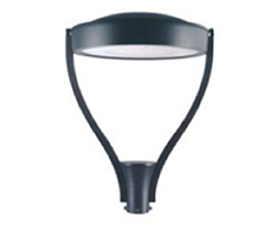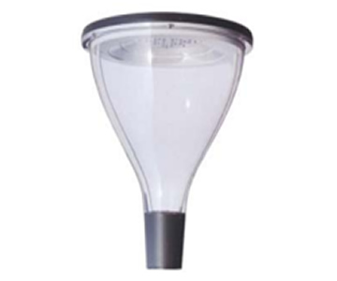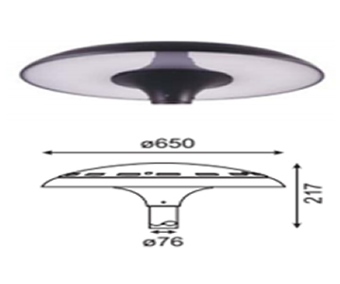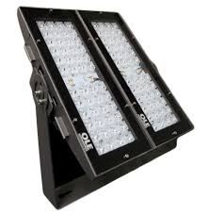

Nikkon – Malaysia:

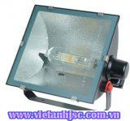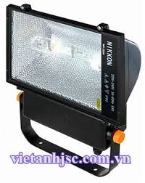

Cable & System LS Vina (made by Technical of Korea)

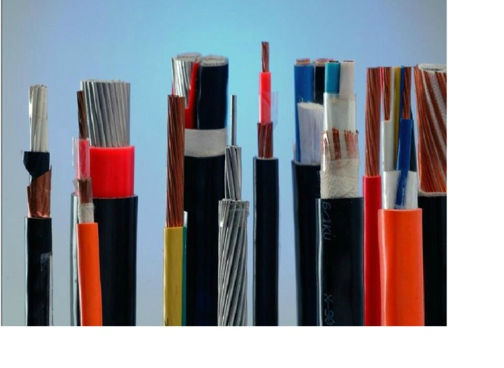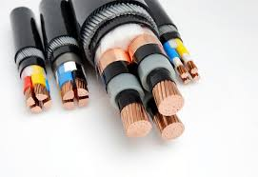

CONSTRUCTION CAPACITY

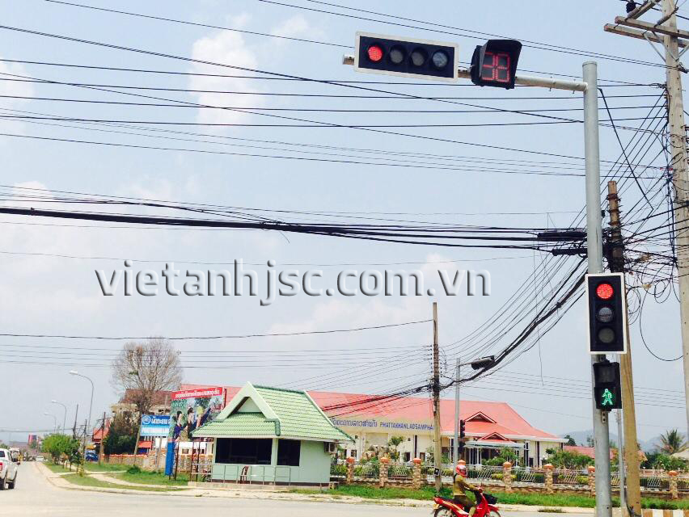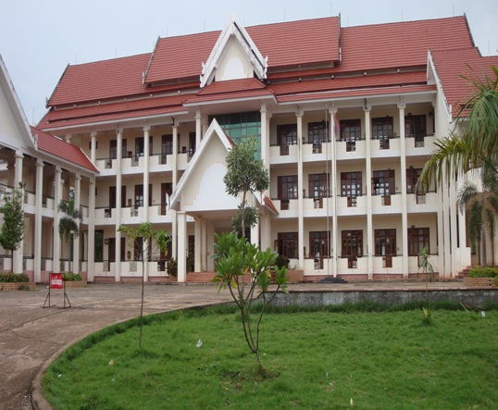

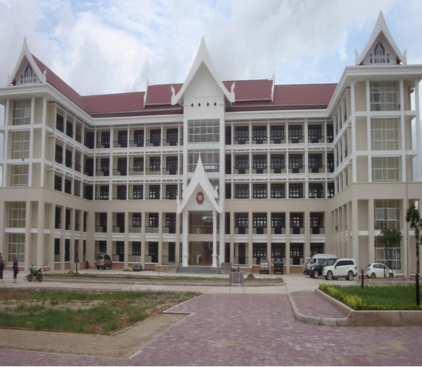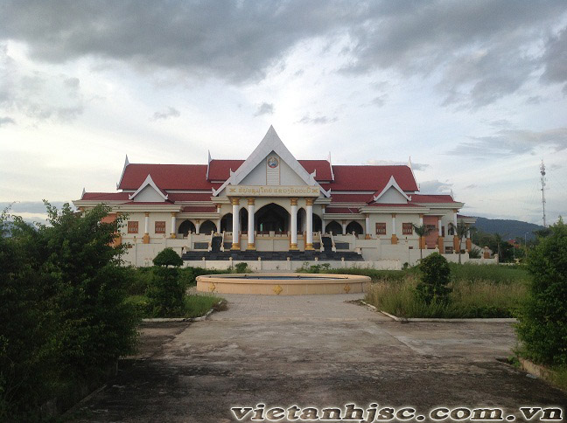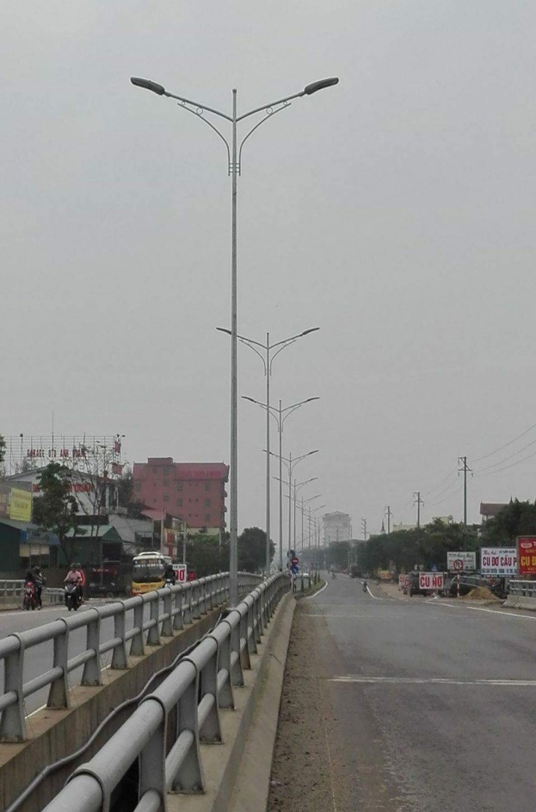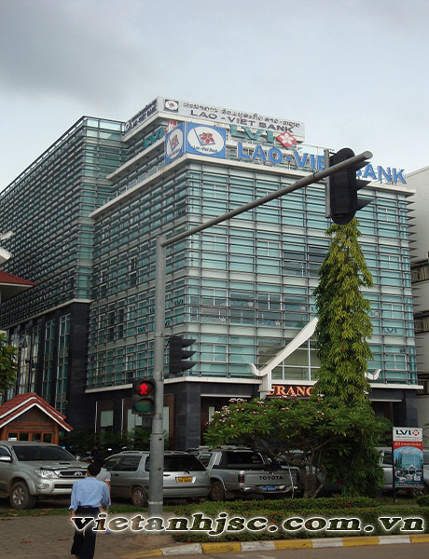
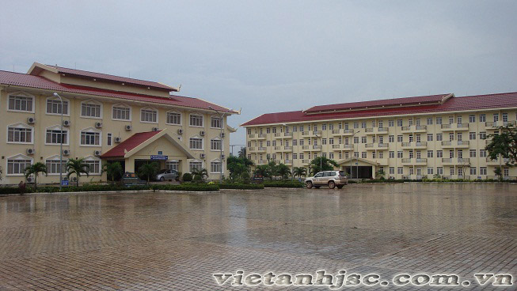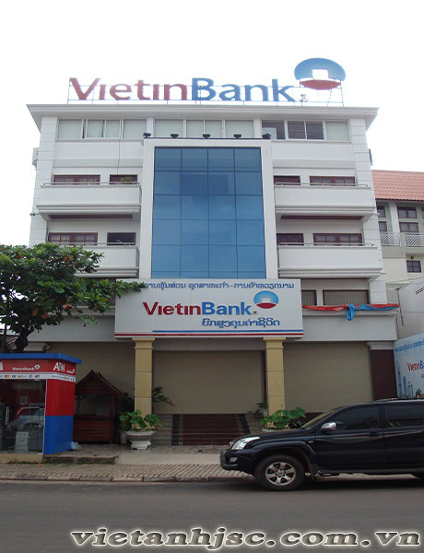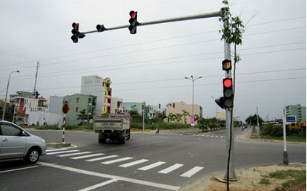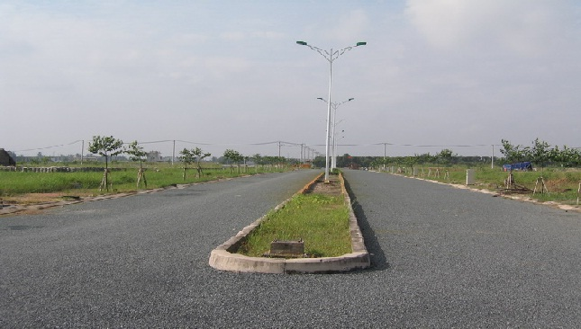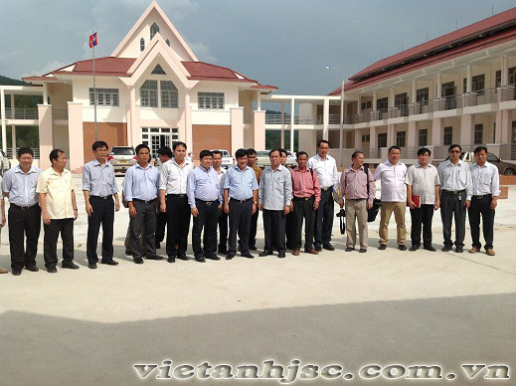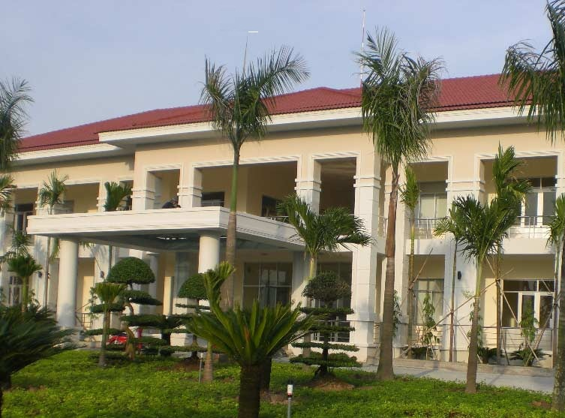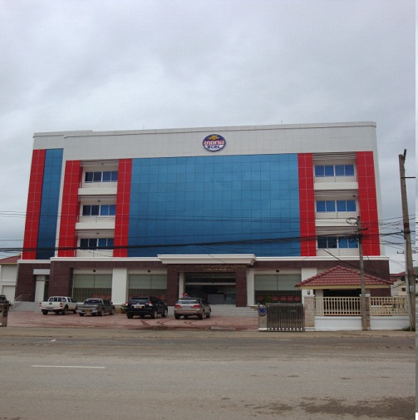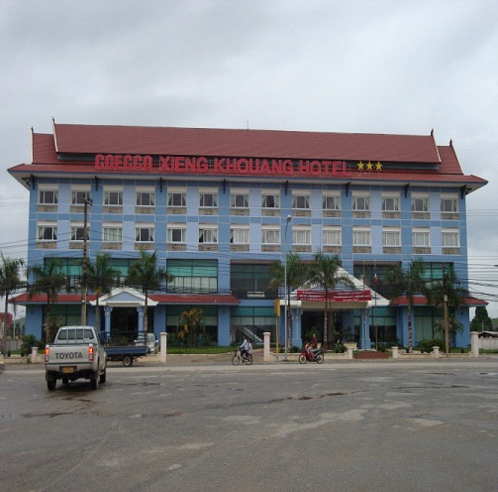

Thanks for reading
Good day, good luck

